**ENDANGERED SPECIES DAY**

* An endangered species is a species that is very likely to become extent in the near future.
* GIANT PANDA

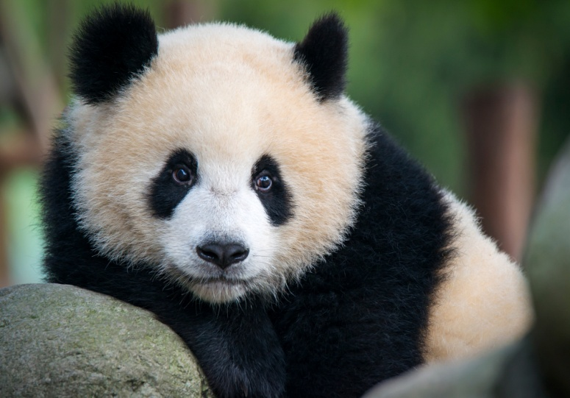

* Scientific name- Ailuropoda melanoleuca
* Population- 1,864 in the wild
* Weight- 220 to 330 pounds
* Height- Adults can grow to more than four feet.
* Habitats- Temperate broadleaf and mixed forests of southwest china.
* TIGER

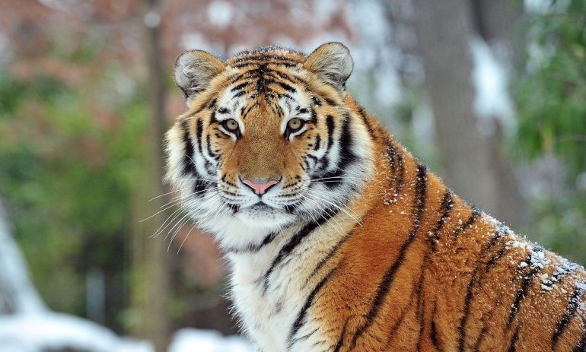

* Scientific name- Panthera tigris
* Population- 3,900
* Weight- male(220kg),female(140kg)
* Height- 90cm to 110cm (at shoulder)
* Habitat- Tropical forests of the Indian sub-continent.
* HAWKSBILL TURTLE

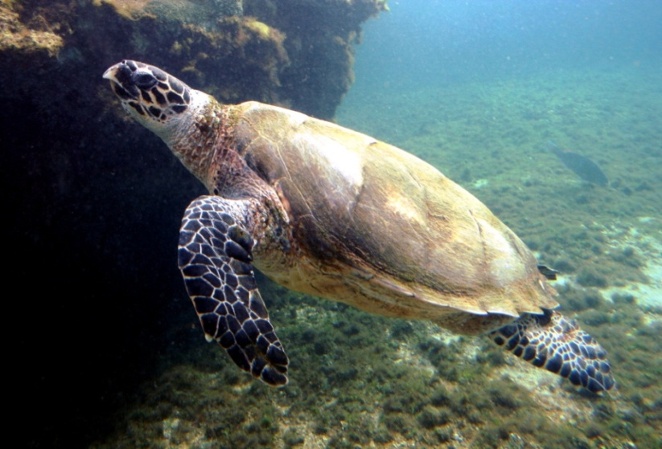

* Scientific name- Eretmochelys imbricate
* Population- 8,000
* Weight- Between 100 and 150 pounds
* Height- 2.5 to 3 feet (in adults)
* Habitat- Tropical Oceans in Coral Reef
* THE GOLDEN TOAD

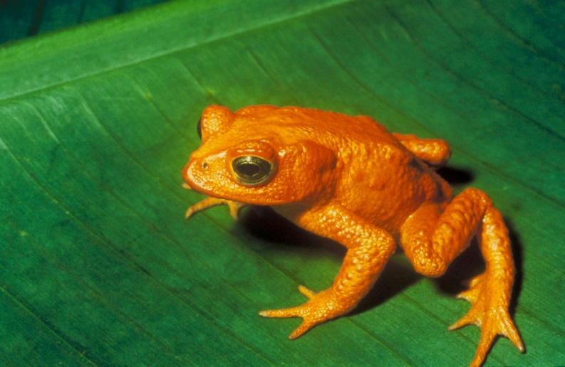

* Scientific Name- Incillius periglenes
* Population- 1,500 in adults
* Weight- around 1 ounce
* Height- 2.2 inches
* Habitat- Wet, montane area of the forest in northern Costa Rica.
* GREAT INDIAN BUSTARD

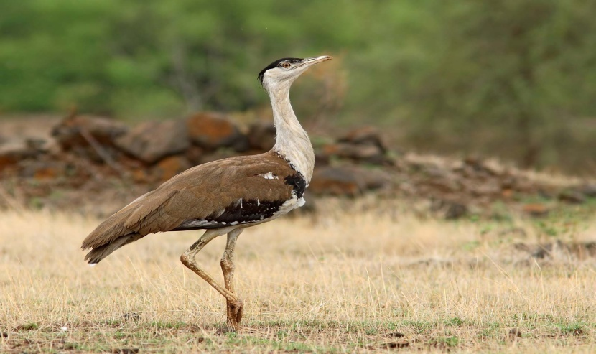

* Scientific name- Ardeotis nigriceps
* Population- 150
* Weight- 4 feet high
* Height- 15kg
* Habitat- Dry grasslands on Indian sub-continent.